The routing table

Router packet forwarding video

.

Messages within and between networks - part 1 video

.

Messages within and between networks - part 2 video

.

Ting table entries

**Routers move info between local and remote networks. To do this, routers must use routing tables to store info.**

Routing tables are not concerned with the addresses of individual hosts.

**Routing tables contain** the addresses of networks, and the best path to reach those networks

**Entries can be made to the routing table in 2 ways:**

- Dynamically updated by info received from other routers in network

- manually entered by a network administrator

**Routers use the routing tables to determine which interface to use to forward a msg to its intended destination**

If router cannot determine where to forward a msg, it will drop it.

**Network administratiors configure a static default route that is placed into the routing table so that a packet will not be dropped due to the destination network not being in the routing table.**

**A default route is the interface through which the router forwards a packet containing an unknown destination IP network address.**

**S**

**This default route usually connects to another router that can forward the packet towards its final destination network**

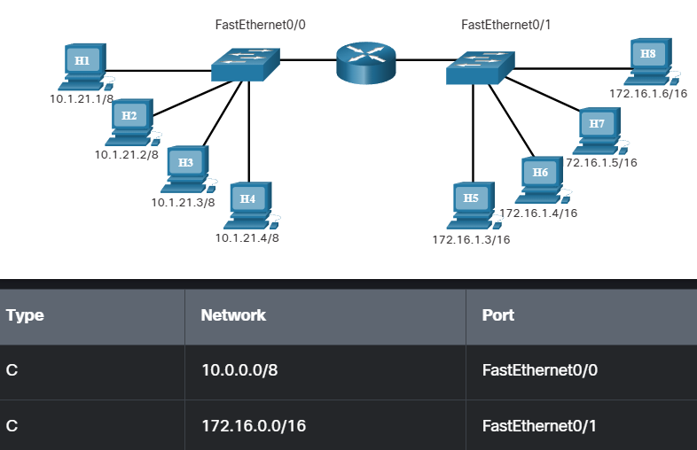

The default gateway

**The method that a host uses to send msg to a destination on a remote network differs from the way a host sends msg on the same local network**

When a host needs to send a msg to another host located on the same network, it will forward the msg directly

(host uses ARP to discover the MAC address of the destination host. The IPv4 packet contains the destination IPv4 address and encapsulates the packet into a frame containing the MAC address of the destination and forwards it out)

When host wants to send msg to a remote network, it must use the router

**The host includes the IP address of the destination host within the packet just like before.**

**However, when it encapsulates the packet into a frame, it uses the MAC address of the router as the destination for the frame.**

In this way, the router will receive and accept the frame based on the MAC address.

Host determines the MAC address from:

IPv4 address of the router that is asigned as its default gateway address

From this it uses ARP to determine the MAC address. The MAC address of the router is then placed in the frame, destined for another network

It is important that the correct default gateway be configured on each host on the local network. If no default gateway is configured in the host TCP/IP settings, or if the wrong default gateway is specified, messages addressed to hosts on remote networks cannot be delivered

